Lab-6 WAP to study Using cut,not,fail predicates in prolog.

Procedure:-

Write a prolog program having facts in clauses section for predicate student(studentname,branchname).

Use cut !, fail and not predicates to:

* Display list of all students
* Display list of students for given specific branch.
* Display list of students excluding specific branch

# Code:

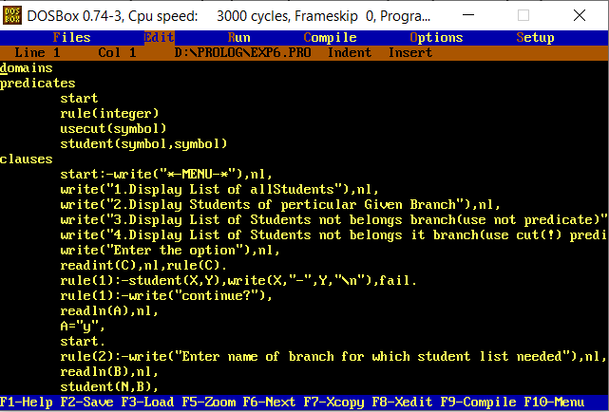

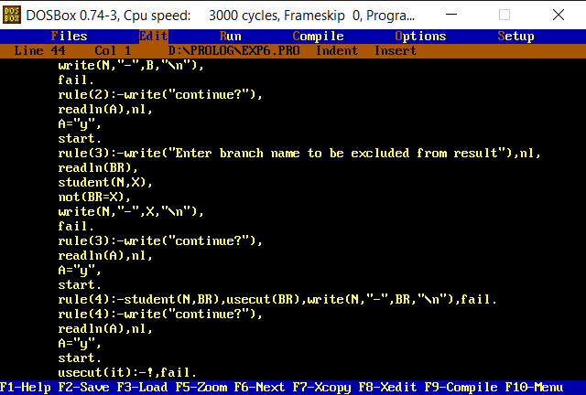

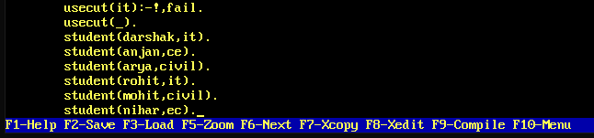

domains predicates

start rule(integer) usecut(symbol)

student(symbol,symbol)

clauses

start:-write("*-MENU-*"),nl, write("1.Display List of allStudents"),nl,

write("2.Display Students of perticular Given Branch"),nl,

write("3.Display List of Students not belongs branch(use not predicate)"),nl,

write("4.Display List of Students not belongs it branch(use cut(!) predicate)"),nl, write("Enter the option"),nl,

readint(C),nl,rule(C).

rule(1):-student(X,Y),write(X,"-",Y,"\n"),fail. rule(1):-write("continue?"),

readln(A),nl,

A="y",

start.

rule(2):-write("Enter name of branch for which student list needed"),nl, readln(B),nl,

student(N,B), write(N,"-",B,"\n"), fail.

rule(2):-write("continue?"), readln(A),nl,

A="y",

start.

rule(3):-write("Enter branch name to be excluded from result"),nl, readln(BR),

student(N,X), not(BR=X), write(N,"-",X,"\n"), fail.

rule(3):-write("continue?"), readln(A),nl,

A="y",

start.

rule(4):-student(N,BR),usecut(BR),write(N,"-",BR,"\n"),fail. rule(4):-write("continue?"),

readln(A),nl,

A="y",

start.

usecut(it):-!,fail. usecut(_). student(darshak,it). student(anjan,ce). student(arya,civil). student(rohit,it). student(mohit,civil). student(nihar,ec).

# Output:

